NAVRO’ZBEK SHAKAROV

<?php

$x = 2;

$y = 3;

if($y > 0 && $x > 0){

$result = true;

}else {

$result = false;

}

echo $result;

?>  


<?php

$x = 2; $y = 3; if (($x > 0 && $x < 1) || ($y > 0 && $y < 1)) { $result = true; } else { $result = false; } echo $result;

?>



<?php

$x = 2;

$y = 3;

$x1 = 4;

$y1 = 5;

$x2 = 6;

$y2 = 7;

if (($x > $x1 && $y > $y1) && ($x < $x2 && $y < $y2) && ($x1 < $x2 && $y1 < $y2)) {

$result = true;

} else {

$result = false;

}

echo $result;

?>  


<?php

$a = 3;

$b = 3;

$c = 3;

if ($a == $b && $b == $c) {

$result = true;

} else {

$result = false;

}

echo $result;

?>  


<?php

$a = 4;

$b = 4;

$c = 4;

if ($a == $b || $b == $c || $c == $a) {

$result = true;

} else {

$result = false;

}

echo $result;

?>  
  
<?php

$a = 3;

$b = 4;

$c = 5;

if (($a\*\*2 + $b\*\*2 == $c\*\*2) || ($a\*\*2 + $c\*\*2 == $b\*\*2) || ($b\*\*2 + $c\*\*2 == $a\*\*2)) {

$result = true;

} else {

$result = false;

}

echo $result;

?>  
  
<?php

$a = 3;

$b = 4;

$c = 5;

if (($a + $b > $c) && ($b + $c > $a) && ($c + $a > $b)) {

$result = true;

} else {

$result = false;

}

echo $result;

?>  


<?php

$x = 2;

$y = 3;

if (($x + $y) % 2 == 0) {

echo "Berilgan ($x, $y) maydon oq";

} else {

echo "Berilgan ($x, $y) maydon siyohrang";

}

?>  


<?php

$x1 = 3;

$y1 = 4;

$x2 = 5;

$y2 = 6;

if (($x1 + $y1) % 2 == ($x2 + $y2) % 2) {

echo "Berilgan maydonlar bir xil rangda";

} else {

echo "Berilgan maydonlar farqli rangda";

}

?>



<?php

$x1 = 2;

$y1 = 3;

$x2 = 4;

$y2 = 5;

if ((abs($x1 - $x2) == 1 && abs($y1 - $y2) == 2) || (abs($x1 - $x2) == 2 && abs($y1 - $y2) == 1)) {

echo "Ruh bir yurishda bir maydondan ikkinchisiga o'ta oladi";

} else {

echo "Ruh bir yurishda bir maydondan ikkinchisiga o'ta olmaydi";

}

?>



<?php

$x1 = 4;

$y1 = 4;

$x2 = 6;

$y2 = 6;

if ($x1 == $x2 || $y1 == $y2 || abs($x1 - $x2) == abs($y1 - $y2)) {

echo 1;

} else {

echo 0;

}

?>



<?php

$x1 = 2;

$y1 = 2;

$x2 = 5;

$y2 = 5;

if (abs($x1 - $x2) == abs($y1 - $y2)) {

echo 1;

} else {

echo 0;

}

?>



<?php

$x1 = 1;

$y1 = 2;

$x2 = 3;

$y2 = 4;

if (abs($x1 - $x2) == abs($y1 - $y2) || $x1 == $x2 || $y1 == $y2) {

echo 1;

} else {

echo 0;

}

?>



<?php

$x1 = 1;

$y1 = 2;

$x2 = 2;

$y2 = 4;

if ((abs($x1 - $x2) == 1 && abs($y1 - $y2) == 2) || (abs($x1 - $x2) == 2 && abs($y1 - $y2) == 1)) {

echo 1;

} else {

echo 0;

}

?>



If

<?php

$a=2;

if($a>0){

$a1=$a+1;

echo $a1;

}

else{

echo $a;

}

?>

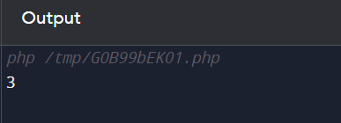

<?php

<?php

$a=-1;

if($a>0){

$a1=$a+1;

echo $a1;

}

else{

$a2=$a-2;

echo $a2;

}

?>

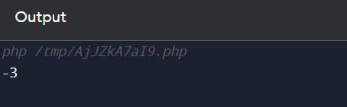

<?php

$a=-2;

if($a>0){

$a1=$a+1;

echo $a1;

}

else if($a<0){

$a3=$a-2;

echo $a3;

}

else{

echo "10";

}

?>

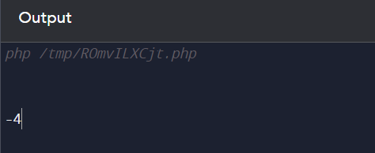

<?php

$a=-3;

$b=2;

$c=2;

if($a>0 and $b>0 and $c>0){

echo "3 ta son ham musbat";

}

else if($a>0 and $b>0 and $c<0){

echo "a va b son musbat";

}

else if($a>0 and $b<0 and $c>0){

echo "a va c son musbat";

}

else if($a<0 and $b>0 and $c>0){

echo "b va c son musbat";

}

else if($a<0 and $b<0 and $c>0){

echo "c son musbat";

}

else if($a>0 and $b<0 and $c<0){

echo "a son musbat";

}

else if($a<0 and $b>0 and $c<0){

echo "b son musbat";

}

else{

echo "hamma son maniy";

}

?>

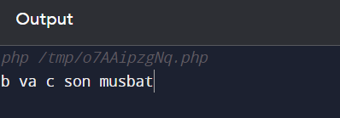

<?php

$a=-3;

$b=-2;

$c=2;

if($a>0 and $b>0 and $c>0){

echo "3 ta son ham musbat";

}

else if($a>0 and $b>0 and $c<0){

echo "a va b son musbat c son manfiy";

}

else if($a>0 and $b<0 and $c>0){

echo "a va c son musbat b son manfiy";

}

else if($a<0 and $b<0 and $c>0){

echo "a va b son manfiy c musbat";

}

else if($a>0 and $b<0 and $c<0){

echo "a son musbat b va c manfiy";

}

else if($a<0 and $b>0 and $c<0){

echo "b son musbat a va c manfiy";

}

else if($a<0 and $b<0 and $c>0){

echo "c son musbat a va b manfiy";

}

else{

echo "hamma son manfiy";

}

?>

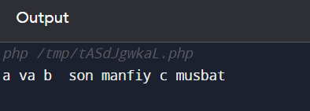

<?php

$a=-3;

$b=9;

if($a>$b){

echo "$a>$b dan";

}

else{

echo "$a<$b";

}

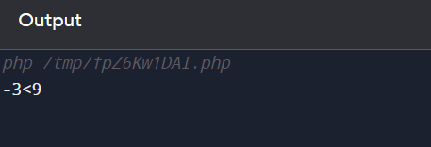

<?php

$a=-3;

$b=9;

if($a>$b){

echo "2-son kichkina";

}

else{

echo "1-son kichkina";

}

?>

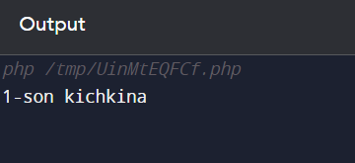

<?php

$a=21;

$b=19;

if($a>$b){

echo "$a kattasi $b kichiki";

}

else{

echo "$b kattasi $a kichiki"; }?>

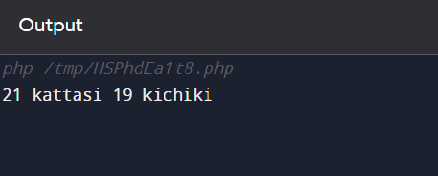

<?php

$a=21.6;

$b=19.9;

if ($a<$b){

echo "$a kichik $b dan";

}

else if ($a>$b){

$a=$a-$b;

echo "$a kichik $b dan";

}

?>

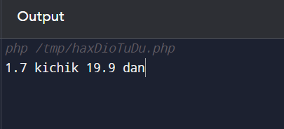

<?php

$a=21.9;

$b=21.9;

if ($a!=$b){

if($a>$b){

echo " $a";

}

else{

echo "$b";

}

}

else{

echo "0";

}?>

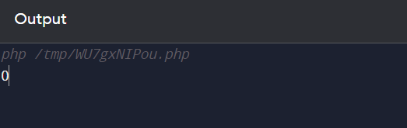

If 11.

<?php

function numbers($A, $B) {

if ($A != $B) {

return max($A, $B);

} else {

return 0;

}

}

// Test qilish

$A = 10;

$B = 15;

$result = numbers($A, $B);

echo "Natija: $result"; // Chiqaradi: 15

$A = 20;

$B = 5;

$result = numbers($A, $B);

echo "\nNatija: $result"; // Chiqaradi: 20

$A = 7;

$B = 7;

$result = numbers($A, $B);

echo "\nNatija: $result"; // Chiqaradi: 0

?>

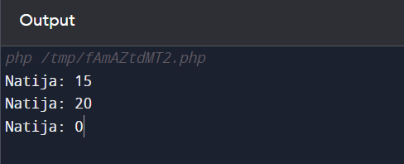

<?php

function findSmallest($num) {

// Uchta sonni kichigini topish

$sma = $num[0];

foreach ($num as $num) {

if ($num < $sma) {

$sma = $num;

}

}

return $sma;

}

// Test qilish

$num = array(10, 5, 7);

$sma = findSmallest($num);

echo "Kichik son: $sma"; // Chiqaradi: 5

?>



<?php

function findMiddle($num1, $num2, $num3) {

// Uchta sonni o'rtachasi

$middle = $num1;

// Katta sonni topish

if ($num1 >= $num2 && $num1 >= $num3) {

if ($num2 >= $num3) {

$middle = $num2;

} else {

$middle = $num3;

}

}

// Kichik sonni topish

elseif ($num1 <= $num2 && $num1 <= $num3) {

if ($num2 <= $num3) { $middle = $num2;

} else { $middle = $num3; } }

return $middle;}

// Test qilish

$num1 = 10;

$num2 = 5;

$num3 = 7;

$middle = findMiddle($num1, $num2, $num3);

echo "O'rta son: $middle"; // Chiqaradi: 7

?>

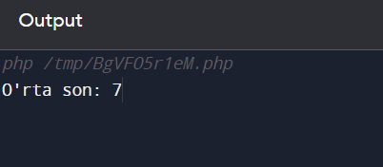

<?php

function printMinMax($num1, $num2, $num3) {

// Sonlarni to'plab, kichikdan kattaga tartiblash

$numbers = array($num1, $num2, $num3);

sort($numbers);

// Kichik sonni ekranga chiqarish

echo "Kichik son: " . $numbers[0] . "<br>";

// Katta sonni ekranga chiqarish

echo "Katta son: " . $numbers[2];

}

// Test qilish

$num1 = 10;

$num2 = 5;

$num3 = 7;

printMinMax($num1, $num2, $num3);

?>

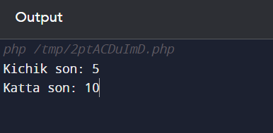

If 15.

<?php

function printTwoLargestSum($num1, $num2, $num3) {

// Sonlarni to'plab, tartiblash

$numbers = array($num1, $num2, $num3);

rsort($numbers);

// Ikki eng katta sonni topish

$largest1 = $numbers[0];

$largest2 = $numbers[1];

// Ikki eng katta sonni ekranga chiqarish

echo "Ikki eng katta son: $largest1 va $largest2";

}

// Test qilish

$num1 = 10;

$num2 = 5;

$num3 = 7;

printTwoLargestSum($num1, $num2, $num3);

?>

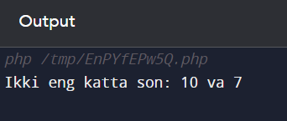

<?php

function swapIfNeeded(&$a, &$b) {

if ($a > $b) {

$temp = $a;

$a = $b;

$b = $temp;

}

}

// A, B, va C ni olish

$A = 10;

$B = 5;

$C = 7;

// Sonlarni o'sish tartibida tartiblash

swapIfNeeded($A, $B);

swapIfNeeded($B, $C);

swapIfNeeded($A, $B);

// Qiymatlarni ekranga chiqarish

echo "A: $A, B: $B, C: $C";

?>

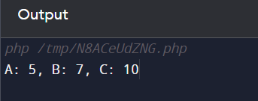

<?php

function swapIfNeeded(&$a, &$b) {

if ($a > $b) {

$temp = $a;

$a = $b;

$b = $temp;

}

}

// A, B, va C ni olish

$A = 10;

$B = 5;

$C = 7;

// Sonlarni o'sish tartibida tartiblash

swapIfNeeded($A, $B);

swapIfNeeded($B, $C);

swapIfNeeded($A, $B);

// Qiymatlarni ekranga chiqarish

echo "A: $A, B: $B, C: $C";

?>

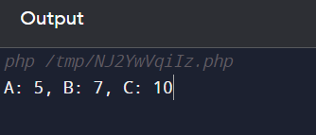

<?php

function findUniqueNumber($num1, $num2, $num3) {

if ($num1 == $num2) {

return $num3;

} elseif ($num1 == $num3) {

return $num2;

} else {

return $num1;

}

}

// Test qilish

$num1 = 5;

$num2 = 7;

$num3 = 5;

$uniqueNumber = findUniqueNumber($num1, $num2, $num3);

echo "Tartib raqami aniqlangan bitta son: $uniqueNumber";

?>

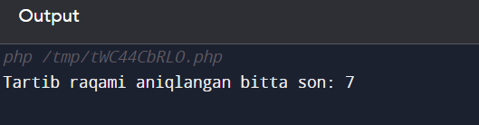

If 19.

<?php

function findUniqueNumber($num1, $num2, $num3, $num4) {

if ($num1 == $num2 && $num1 == $num3) {

return $num4;

} elseif ($num1 == $num2 && $num1 == $num4) {

return $num3;

} elseif ($num1 == $num3 && $num1 == $num4) {

return $num2;

} elseif ($num2 == $num3 && $num2 == $num4) {

return $num1;

}

}

// Test qilish

$num1 = 5;

$num2 = 7;

$num3 = 5;

$num4 = 5;

$uniqueNumber = findUniqueNumber($num1, $num2, $num3, $num4);

echo "Tartib raqami aniqlangan bitta son: $uniqueNumber";?> 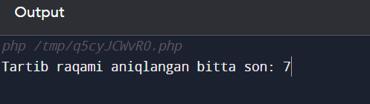

<?php

function distance($x1, $y1, $x2, $y2) {

return sqrt(pow($x2 - $x1, 2) + pow($y2 - $y1, 2));

}// Uchta nuqta

$xA = 1;

$yA = 2;

$xB = 4;

$yB = 6;

$xC = 7;

$yC = 8;

// Masofalar

$distanceAB = distance($xA, $yA, $xB, $yB);

$distanceAC = distance($xA, $yA, $xC, $yC);

$distanceBC = distance($xB, $yB, $xC, $yC);

if ($distanceAB <= $distanceAC && $distanceAB <= $distanceBC) {

echo "Eng yaqin nuqta A va B orasidagi masofa: $distanceAB";

} elseif ($distanceAC <= $distanceAB && $distanceAC <= $distanceBC) {

echo "Eng yaqin nuqta A va C orasidagi masofa: $distanceAC";

} else { echo "Eng yaqin nuqta B va C orasidagi masofa: $distanceBC";

}?>

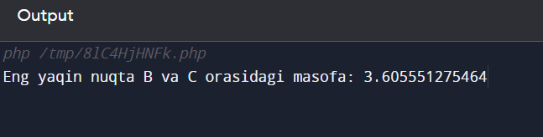

<?php

function findPointLocation($x, $y) {

if ($x == 0 && $y == 0) {

return 0;

} elseif ($x == 0 || $y == 0) {

return 1;

} elseif ($x != 0 && $y != 0) {

return 3;

}

}

// Koordinatalar

$x = 0;

$y = 5;

// Nuqta joylashgan joyini topish

$location = findPointLocation($x, $y);

// Natijani chiqarish

echo "Nuqta joylashgan joy: $location";

?>

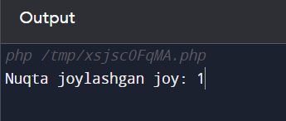

<?php

function findPointLocation($x, $y) {

if ($x == $y) {

return "Nuqta chorak koordinata o'qlarining orasida joylashgan";

} else {

return "Nuqta boshqa joyda joylashgan";

}

}

// Koordinatalar

$x = 3;

$y = 3;

// Nuqta joylashgan joyini topish

$location = findPointLocation($x, $y);

// Natijani chiqarish

echo "Nuqta joylashgan joy: $location";

?>

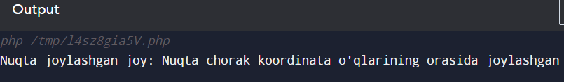

<?php

function findFourthCoordinate($side1, $side2, $side3) {

return $side3 - abs($side1 - $side2);

}

// Uchta tomon uzunligi

$side1 = 5;

$side2 = 7;

$side3 = 9;

// To'rtinchining uchinchisi koordinatini topish

$fourthCoordinate = findFourthCoordinate($side1, $side2, $side3);

// Natijani chiqarish

echo "To'rtinchining uchinchisi koordinat: $fourthCoordinate";

?>

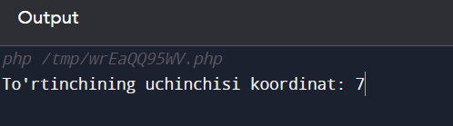

<?php

function calculateFunction($x) {

if ($x > 0) {

return 2 \* sin($x);

} else {

return $x - 6;

}

}

// Test qilish

$x = 3;

$result = calculateFunction($x);

echo "f($x) = $result"; // Agar x > 0 bo'lsa, sin(3) \* 2; aks holda 3 - 6 = -3.

?>

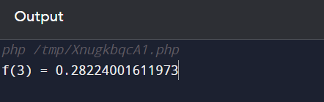

<?php

function calculateFunction($x) {

if ($x < -2 || $x > -3) {

return 2 \* $x;

} else {

return -3 \* $x;

}

}

// Test qilish

$x = -2.5;

$result = calculateFunction($x);

echo "f($x) = $result"; // Agar x < -2 yoki x > -3 bo'lsa, 2 \* x; aks holda -3 \* x.

?>

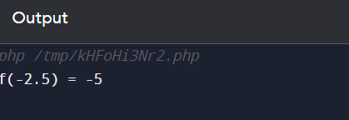

<?php

function calculateFunction($x) {

if ($x <= 0) {

return -$x;

} elseif ($x > 0 && $x < 2) {

return $x \* $x;

} else {

return 4;

}

}

// Test qilish

$x = 1.5;

$result = calculateFunction($x);

echo "f($x) = $result";

?>

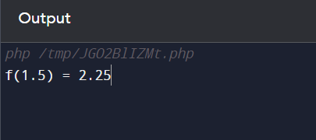

If 27.

<?php

function calculateFunction($x) {

if ($x < 0) {

return 0;

} elseif ($x % 2 == 0 && $x % 2 != 0) {

return 1;

} else {

return -1;

}

}

// Test qilish

$x = 3;

$result = calculateFunction($x);

echo "f($x) = $result"; // Agar x < 0 bo'lsa, 0; agar x muzoj toq son bo'lsa, 1; agar x juft son bo'lsa, -1.

?>

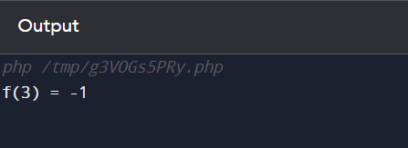

<?php

function countDaysInYear($year) {

if (($year % 4 == 0 && $year % 100 != 0) || $year % 400 == 0) {

return 366;

} else {

return 365;

}

}

// Test qilish

$year = 2024;

$days = countDaysInYear($year);

echo "Yilda $days kun bor";

?>

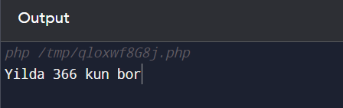

<?php

function classifyNumber($number) {

if ($number == 0) {

echo "Berilgan son nolga tengdir.";

} elseif ($number > 0 && $number % 2 != 0) {

echo "Berilgan son musbat toq son.";

} elseif ($number < 0 && $number % 2 == 0) {

echo "Berilgan son manfiy juft son.";

} else {

echo "Berilgan son musbat juft son.";

}

}

// Test qilish

$number = 7;

classifyNumber($number);

?>



<?php

function yozuvShaklidaChiqar($son) {

$onlar = array(

"", "o'n", "yigirma", "o'ttiz", "qirq", "ellik", "oltmish", "yetmish", "sakson", "to'qson"

);

$birliklar = array(

"", "bir", "ikki", "uch", "to'rt", "besh", "olti", "yetti", "sakkiz", "to'qqiz"

);

$yuzlar = array(

"", "bir yuz", "ikki yuz", "uch yuz", "to'rt yuz", "besh yuz", "olti yuz", "yetti yuz", "sakkiz yuz", "to'qqiz yuz"

);

$yuz = floor($son / 100);

$qoldiq = $son % 100;

$o = floor($qoldiq / 10);

$b = $qoldiq % 10;

$yozuv = "";

if ($yuz > 0) {

$yozuv .= $yuzlar[$yuz] . " ";

}

if ($o > 0) {

$yozuv .= $onlar[$o] . " ";

}

if ($b > 0) {

$yozuv .= $birliklar[$b];

}

return $yozuv;

}

$son = 123;

echo yozuvShaklidaChiqar($son);

?>

